Lent 2020 ACQW
Led by Rev. Lynn Mitchell+

HOLY HABITS
for daily Christian Living

PRAYING in
COLOUR

Based on the book by Sybil MacBeth

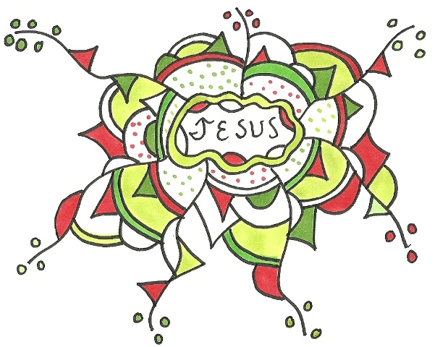

Some notes from Praying in Color
- “Praying in color is an active, meditative, playful prayer practice. It is both process and product. The process involves a re-entry into the childlike world of coloring and improvising. The product is a colorful design or drawing that is a visual reminder of the time spent in prayer.” (p. 5 Praying in Color)
- “The irony and miracle for me is that now, in my adulthood, God has taken one of my passions – color; combined it with one of inadequacies – drawing……..and given me a new way to pray. My grace is sufficient for you, for my power is made perfect in weakness (2 Cor 12:19 NIV)” (p. 6)
- “I’ve never been much a prayer warrior; I cannot fire out eloquent, television-worthy prayers. Instead, I’m more like a prayer popper. I pray a lot, but in fits and spurts…….” (p. 8)
- “Prayer is the glue that holds all the pieces of life together in a spiritual whole.”
- “Since words elude me when I need them most, I learned long ago that I cannot count on quality time with God when I want to pray. I need quantity and regularity. Quality is not something I can predict.”
- “There’s also the risk that instead of praying [for others], I’ll just worry about them. And worry is not a substitute for prayer. Worry is a starting place, but not a staying place.” (p.12)
- Worry invites me into prayer.
- “As a staying place, worry can be self-indulgent, paralyzing, draining, and controlling. It conjures up the dark side of my imaginative gifts and consumes my energy. It is no less evil or titillating than pornography. When I take worry into prayer, [worry] doesn’t disappear, but it becomes smaller. I see it for its true self – an imposter that masks itself as action and lassoes me into inaction. Brought into prayer, it sits next to me and whimpers for its former place of honor and power. When I focus on my prayer, on that conscious effort to engage the presence of God, worry heels, stays, and sometimes rolls over and dies.”
GETTING STARTED
- You will need pencil crayons, coloured markers, crayons……make sure they are of good quality
- You will need paper; buy a drawing pad from an art supply store
- As little or as much time as you want to commit. Half an hour is a good length, but if 15 minutes works…….. If you draw in the morning, you can take the prayer with you during the day; in the evening, they become part of a bedtime blessing.
To begin
- Recite or read a favourite passage of scripture
- Sit in your chair a few minutes and be quiet. Take several deep breaths.
- Say a short prayer to gather the bits of your mind, body, and spirit together.
- Draw a shape on the page.
- In the shape, write the name of a person for whom you wish to pray. OR write your own name. OR write “God” or “Jesus” OR………
- Add detail to the drawing….dots, lines, circles, zigzags, wiggles……whatever your hand wants to do.
- Continue to enhance the drawing. Think of each stroke and moment as the time you spend with the person for whom/to whom you are praying.
- Add more colour. Keep drawing until it feels finished.
- Then draw another shape.
- Write a new name in the middle.
- Repeat the drawing process.
- Repeat………until you are finished/your time has come to an end.
- To finish, spend a concluding moment with each person. Say AMEN if that seems appropriate.
- Take the journal or page with you, if you can. Place it on your desk, the counter, your refrigerator or someplace where your eyes will scan it during the day.
- The next day/time you sit down to pray in colour, you can begin a new drawing, or add to the previous drawing.
