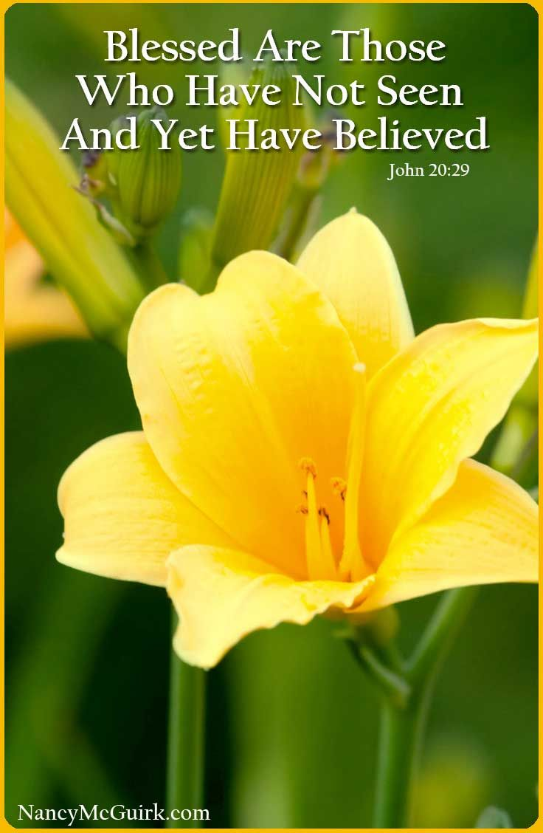**ACQW News ~ Week of April 9th 2021**

**From the Desk of Rev. Lynn+**

My dear Friends in Christ,

Alleluia! Christ is Risen.

The Lord is Risen indeed. Alleluia!

May his grace and peace be with you.

May he fill our hearts with joy.

Despite the discouragement of renewed COVID restrictions, Easter Sunday was a beautiful day, and we were able to enjoy and celebrate some in-person outdoor worship with our drive-thru service at Christ Church. As well, our online service was well-

“attended”, as were all four of our other Holy Week services. Thank you to Bev and Frank Box, Judy Elms, Fred Robinson, Dennis Vince, and Wendy Tice for helping manage our drive-thru. And thank you to Linda in the office for all her work in bulletins copied, deliveries sorted, multiple emails sent, and generally to help keep a hectic Holy Week schedule on the rails.

Bishop Michael Oulton has put the Diocese back into the Red Stage of our *Loving Our Neighbours* pandemic protocols. This means that our church buildings are closed, with the exception of essential activity. However, we will continue to support, encourage, and pray for one another, and look forward to the possibility of some renewed activity – parish picnic, take-out strawberry social – later in the spring.

In the meantime, let’s work together to do all that we can to keep one another safe and healthy. It continues to be a long, long haul but we can do this. We are an Easter people, and we know that the power of God working in us accomplishes infinitely more than we could ask for, or possibly imagine.

With many blessings,

Rev. Lynn+

 Elizabeth C.

Devin H.

Barbara S.

Max G.

Gary P.

Thorbut S.

Nichola R.

|  |
| --- |
|  |
|  |

Dear members of the Anglican Churches

of Quinte West.

As you remember we celebrated the 175th anniversary of Saint George’s church last year. While of our plans had to be postponed or cancelled, we were able to continue with a few initiatives, one of which was the planting of 174 Sugar Maple Trees at Bain Park as well as planting the 175th tree on the church yard grounds, thanks to members of the Highway of Heroes Tree Campaign. This year, we plan to mount two bronze plaques with the names of the donors as well as their dedications. One will be on the wall at St. George’s Church and the second will be on a cairn at Bain Park.

To date we have had 150 trees dedicated at $150.00 each. This leaves just 25 more to go. After the plaques are purchased, the remaining revenue will be split 50:50 with St. George’s Operating Account and the Highway of Heroes Tree Campaign.

This is your last chance to have a permanent memorial to someone special such as a family member, friend or even someone in the community whom you admire and respect. If you are interested in dedicating one of these remaining trees, please contact Linda in the office at 613-394-4244 x 2.

The 175th Anniversary Committee

### THIS WEEK

* Sundays Online @ YouTube “Anglican Quinte”
* Community Meals Tuesday, April 13th at noon
* Bible Study Wednesday, April 14th at 10am via Zoom
* St. George’s Choir Thursday, April 15th 6:30 via Zoom
* Pastoral Care Prayer Circle Members of our ACQW Prayer Circle continue to pray regularly for those on our prayer lists. If you have an addition to the list, please let Linda in the Office know.
* Website [www.anglicanquinte.ca](http://www.anglicanquinte.ca/) is updated regularly.
* Facebook Anglican Churches of Quinte West.
* YouTube Anglican Quinte (you may subscribe to our channel as well).

To Contact Rev. Lynn+ 613.392.1466 revlynnam@gmail.com



One of our ACQW parishioners is wanting to adopt an older dog (3+ years). A smaller breed is preferred. If you know of a dog who is in search of a new home, please contact Rev. Lynn.